1. Introduction Script – Raine D

Our client is Elemore Hall School, and our main point of contact is the headteacher, Michael Hunter. Elemore Hall School is a secondary school based in County Durham. The school supports students who have Social, Emotional and Mental Health Difficulties.

Michael Hunter, their headteacher has asked us to develop a new system to keep track of student grades and progress. This will replace the current system they have in place, Classroom Monitor as it is being discontinued.

The key wants (requests) of the stakeholder is as follows:

* A tracker for Elemore steps
  + ‘Elemore steps’ are how the school keeps track of student progress

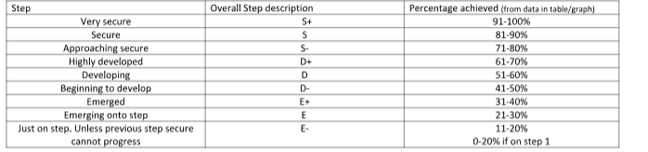

* + - A set of can do statements

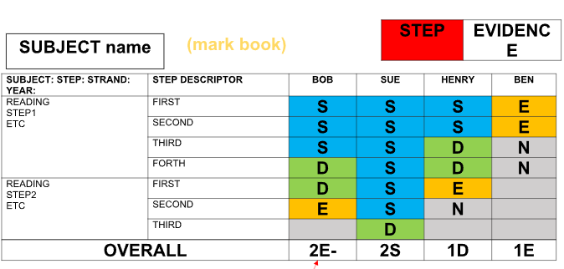

* Academic intervention tracker where the literacy and numeracy skills of a student can be tracked
* The ability to generate academic reports from data that has been input

Our aims:

* An efficient and easy to use system that is useful to the school
* Easy to navigate and use the system
* We aim to ensure data is kept and handled securely as we will be dealing with personal information
* We want to ensure we tailor the system well towards the school. For example we want to get the Elemore steps right because our stakeholder has made clear how important it is to keep track of a student’s progress, even the smallest bit of improvement is important and should be appreciated and acknowledged.